|  |  |  |  |  |
| --- | --- | --- | --- | --- |
| Streamlit Generative AI Application Documentation | | | | |
|  |  | | |  |
|  | | | | |
|  | | Ramesh J.. |  | |

TABLE OF CONTENTS

Introduction 3

1. Features 3

2. Technology Stack 3

3. Installation Guide 4

4. Usage Guide 4

5. License 5

6. Contact Information 5

# Introduction

The Streamlit Generative AI Application is an innovative web application that integrates Google's advanced generative AI models. It provides an interactive platform for users to engage with AI technology for text and image generation. The application showcases how AI can be used for creative content generation and demonstrates the integration of image processing within a Streamlit interface.

# Features

* **Text Generation:** Users can input text prompts to generate contextually relevant and creative content.
* **Image Generation and Modification:** The application supports image-based AI models, allowing users to upload and transform images based on textual prompts.
* **Customizable User Interface:** Featuring a user-friendly sidebar for API key input and model selection.
* **Dynamic Content Display:** Instantly displays the output from the AI models within the app.
* **Custom Banner Display:** A feature demonstrating the ability to integrate custom images within the Streamlit framework.

# Technology Stack

* **Streamlit:** A fast and efficient framework for building data applications. It is used to create the application's web interface.
* **Google Generative AI:** Provides the backend AI models for text and image generation.
* **Python Imaging Library (PIL):** Utilized for image processing and handling within the application.

# Installation Guide

To set up the Streamlit Generative AI Application:

* **Clone the Repository:**

*git clone* [*https://github.com/RameshJajula/GenAI_GUI.git*](https://github.com/RameshJajula/GenAI_GUI.git)

* **Install Dependencies:**

Navigate to the project directory and install the required libraries:

*pip install streamlit google-generativeai PIL*

* **Configure API Key:**

Obtain and configure a Google API key for accessing generative AI models.

# Usage Guide

* **Start the Application:**

Run the app using Streamlit: *streamlit run app.py*

* **Navigating the App:**
* Enter your Google API key in the sidebar.
* Select the desired model type (TextWise or VisionWise).
* For TextWise, enter a prompt and submit for text generation.
* 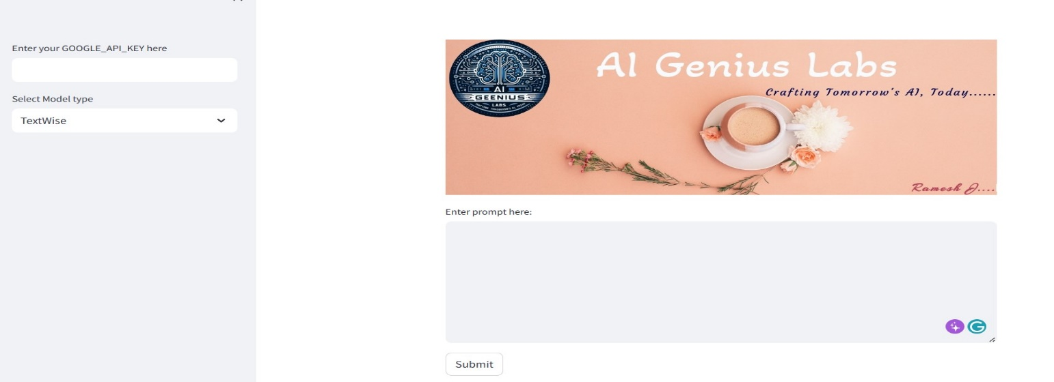
* For VisionWise, upload an image, provide a prompt, and submit to see the AI-transformed image.
* 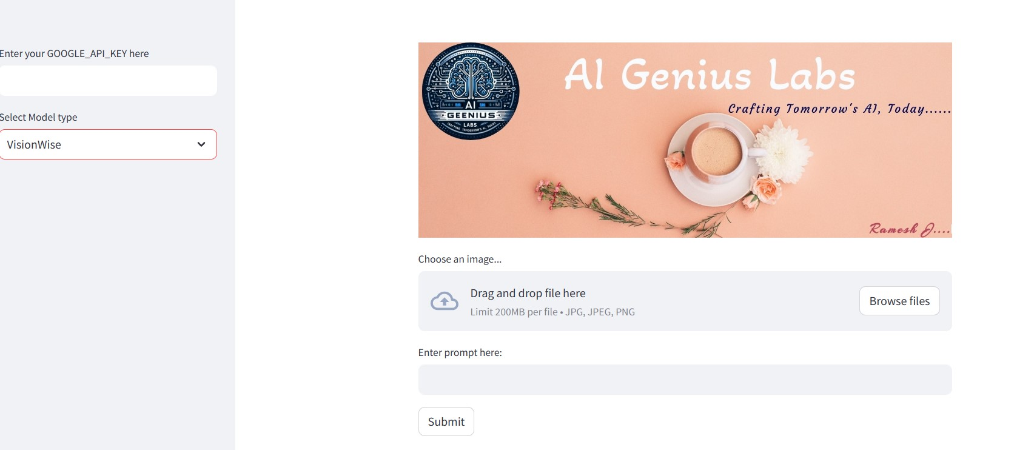

# License

This project is licensed under the MIT License - see the LICENSE file for details.

# Contact Information

For any queries or contributions, please contact Ramesh J at [AIGeniusLabs@gmail.com](mailto:AIGeniusLabs@gmail.com)